# DATA STRUCTURES

# FALL 2023

**LAB 02**

**Learning Outcomes**

In this lab you are expected to learn the following:

* Abstract Data Types
* Templates

**In this lab, you will implement ADT using Templates.**

**Lab Task 1 (20 minutes)**

Writing three similar functions can be avoided if we use templates. Write only one Function which is generic for all data types shown in figure.

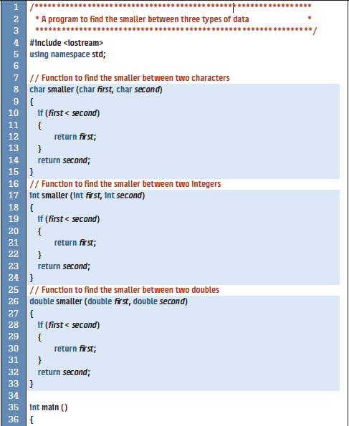

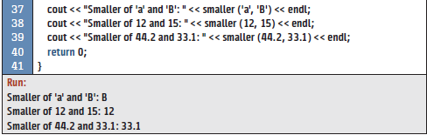

**Lab Task 2(20 minutes)**

You have studied overloading of regular (non-template) functions. We can apply the same concept to function templates. We can overload a function template to have several functions with the same name but different signatures. Normally, the template type is the same, but the number of parameters is different.

You are required to overload the **smaller** template function that you have implemented in task-1 to accept two or three parameters

## Lab Task 3(30 minutes)

* Write a program that take two arrays as input and find the same elements from the arrays.
* Write a program that take two arrays as input and concatenate the arrays but the condition is that there are no same elements in the resultant array

Note: input of the array must be of the type int, char, and float.

## Lab Task 4 (40 minutes)

Consider a scenario of a supermarket which has received the ordered stocks; they receive the stock in the form of boxes. Each box contains some sort of label(i.e: 12, 345.67 and abc) to identify the inside material. This time they have received 30 boxes with the labels given below:

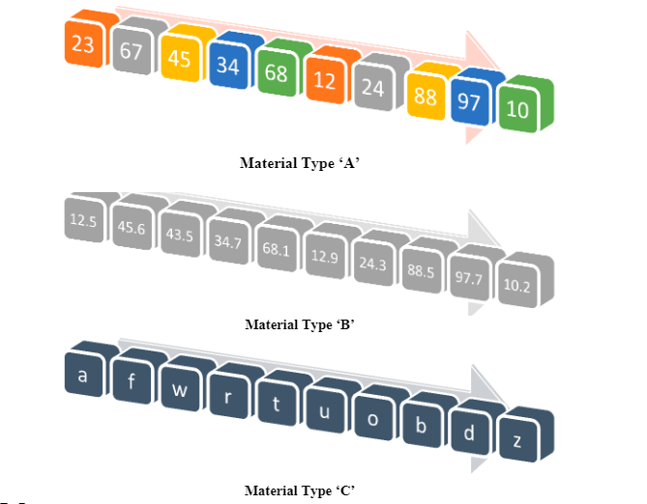

Use the concept of Templates and classes to solve the given scenario.

● Store boxes of similar label together but separate from other label types

● Display collection of each type of boxes

● Find the box with the label having the highest value.